

**MINI-PROJECT’S REPORT**

**ROUND 2**

**LOGIC DESIGN (LAB) – CC01**

**__________ GROUP 9 __________**

**Đoàn Việt Tú – 1952521**

**Trần Minh Trung – 1953052**

**Ngô Nguyễn Khôi Nguyên – 1952544**

**CHAPTER 1: INTRODUCTION**

1. **TOPIC:**

Running LEDs is usually used for decorating stores, buildings, companies. A Running LEDs circuit should support multiple running types.

**Design and implementation a Decorative LED lights system on Altera DE2i-150 board.**

**Functionalities:**

- Support at least 2 rules:

* **Rule 1**: Leds start with a length of 3 at the right edge. Leds run from right to left, when the 3-led line to the left edge, leds navigation from left to right.
* **Rule 2**: LEDs run from the two edges to middle until all LEDs are ON (bright), then turn OFF from left to right.

- Support at least 3 level of running speed on DE2I-150 (frequency): 1Hz, 2Hz, and 4Hz

(You can use higher frequencies for simulation)

- Display rule number, mode, speed on 7-segment LEDs.

- Support 2 mode: **automatic** (LEDs run from rule 1 -> rule 2 -> back to rule 1) and **hand control** (repeat one specified rule).

1. **GOALS:**

Practice and understanding:

* Edge trigger and Level trigger
* Blocking and non-Blocking assignment.
* Experiments on real FPGA technology – DE2I150 board

1. **SOFTWARE AND HARDWARE USED:**

Quartus Prime 19.1 Lite Edition, ModelSim and DE2i-150 FPGA board

1. **INSTRUCTIONS:**

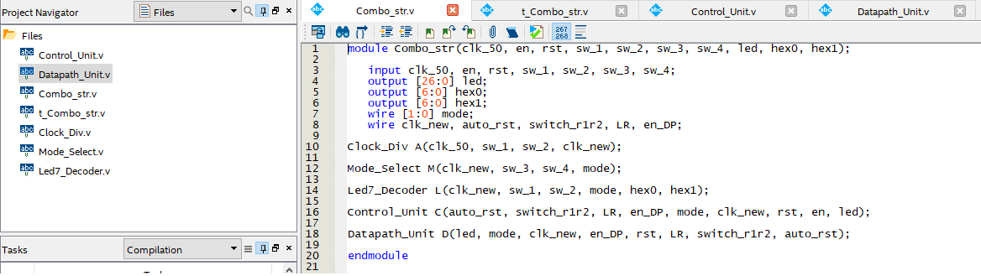

(top-level entity module)

* **LEDs, switches, buttons and 7-segment LEDs used:**
* All LEDs (18 LEDR + 9 LEDG) 🡪 [26:0] led
* Switches:

SW[0], SW[1] (to select SPEED) 🡪 {sw_1, sw_2}

2’b01 (1 Hz), 2’b10 (2 Hz),

2’b11 (4 Hz), 2’b00 (50 MHz - board frequency)

SW[2], SW[3] (to select MODE) 🡪 {sw_3, sw_4}

2’b01 (repeat rule 1), 2‘b10 (repeat rule 2),

2’b11: (automatic), 2’b00: all LEDs are off.

* Buttons:

KEY[0] (reset) 🡪 rst, to set things ready or to switch modes

KEY[1] (enable) 🡪 en, to start running LEDs

* 7-seg LEDs:

HEX0 (display MODE) 🡪 [6:0] hex0

HEX1 (display SPEED) 🡪 [6:0] hex1

* **How it works: (pictures in Chapter 2 to demonstrate)**
* MANUAL/AUTOMATIC: select SPEED, MODE, turn on rst for a second, then turn it off and press en.

For example: to run mode 1 (repeat rule 1) with frequency 50 MHZ, first turn off SW[0], SW[1], then turn off SW[2] and turn on SW[3], turn on KEY[0] for a second and turn it off, then hit KEY[1] to begin.

* SWITCHING MODEs: to switch among three modes manually, first run MODE 1 (or 2, 3), after a while, hit KEY[0] to set things ready, then select SWs to another MODE and turn off KEY[0] to begin.

**CHAPTER 2: DESIGN AND IMPLEMENT**

RTL Viewer:

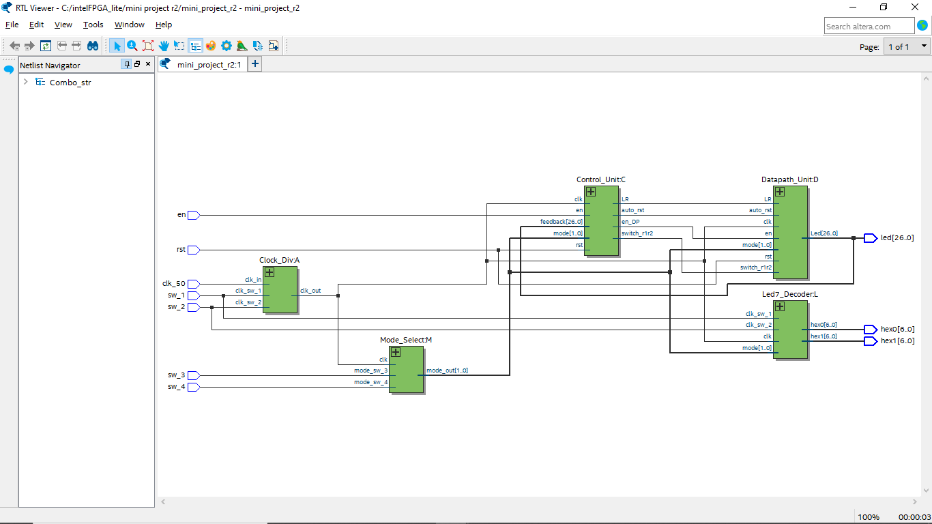

**CHAPTER 3: EXPERIMENTS**

**MODE 1 (REPEAT RULE 1) - 50 MHZ**

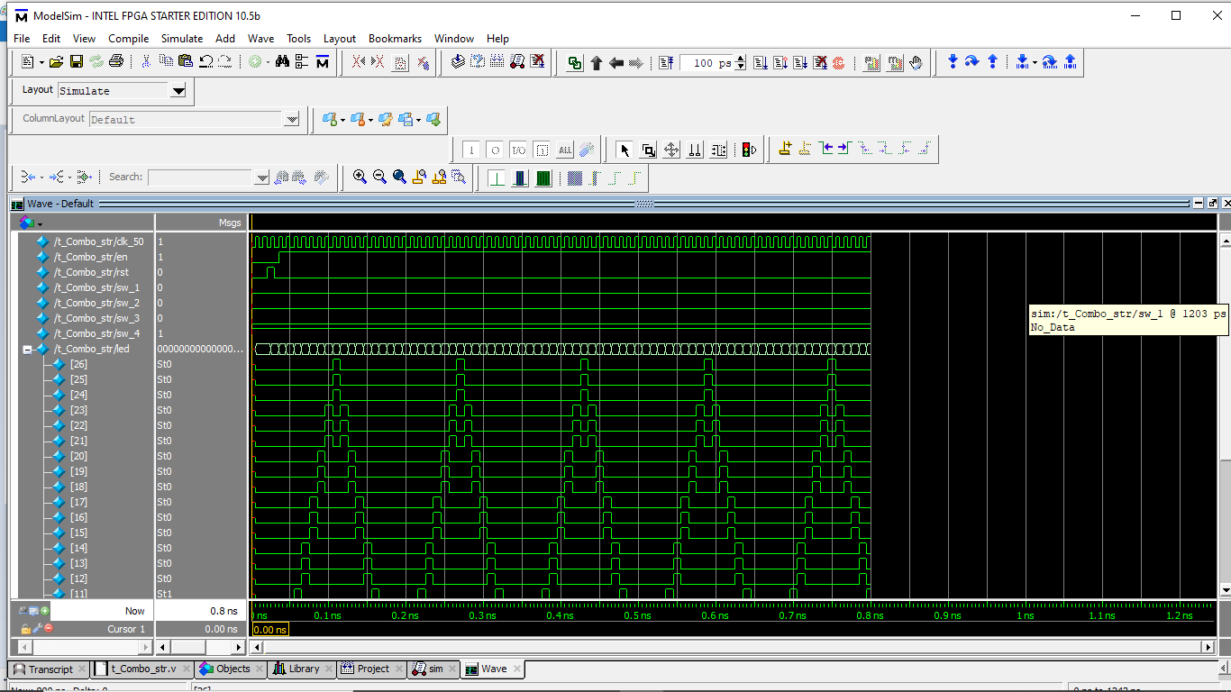

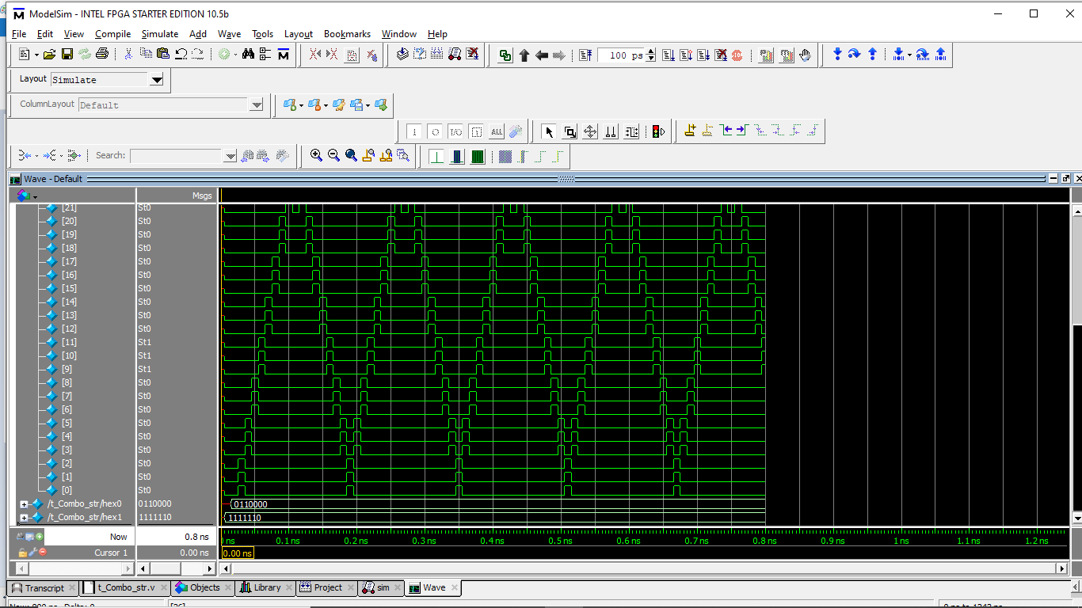

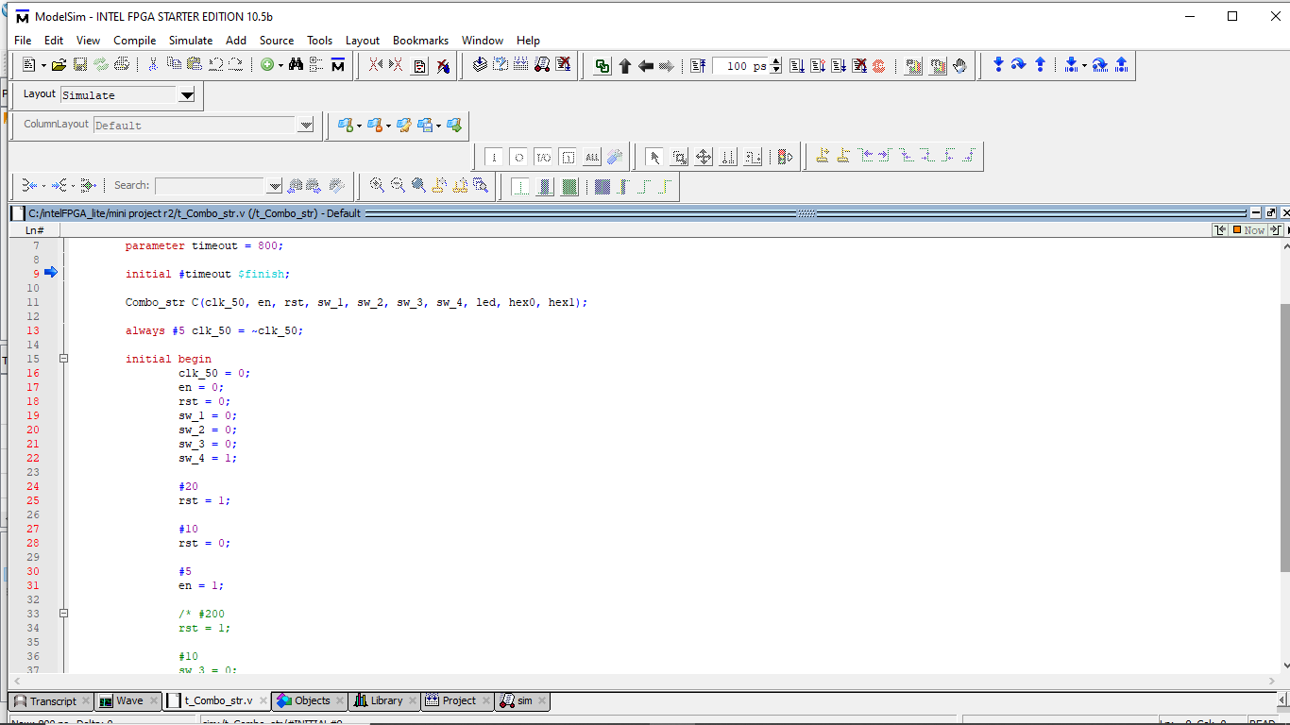

(testbench for mode 1)

**MODE 2 (REPEAT RULE 2) – 50 MHZ**

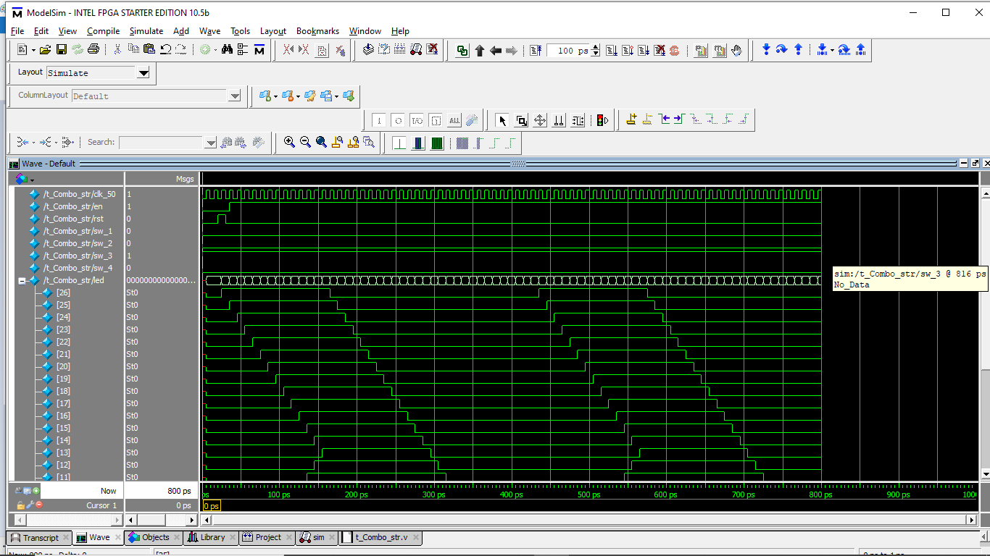

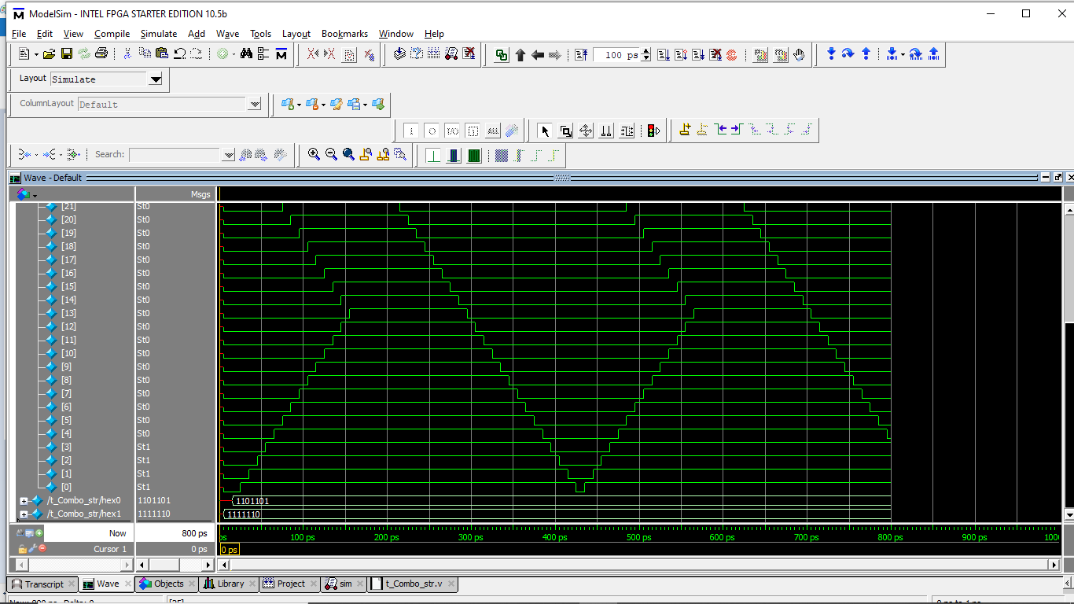

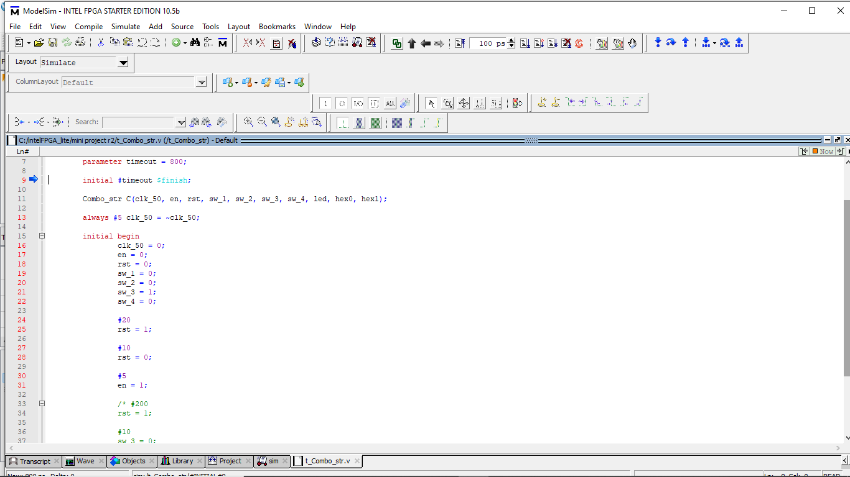

(testbench for mode 2)

**SWITCH FROM MODE 2 TO MODE 1 (MANUALLY)**

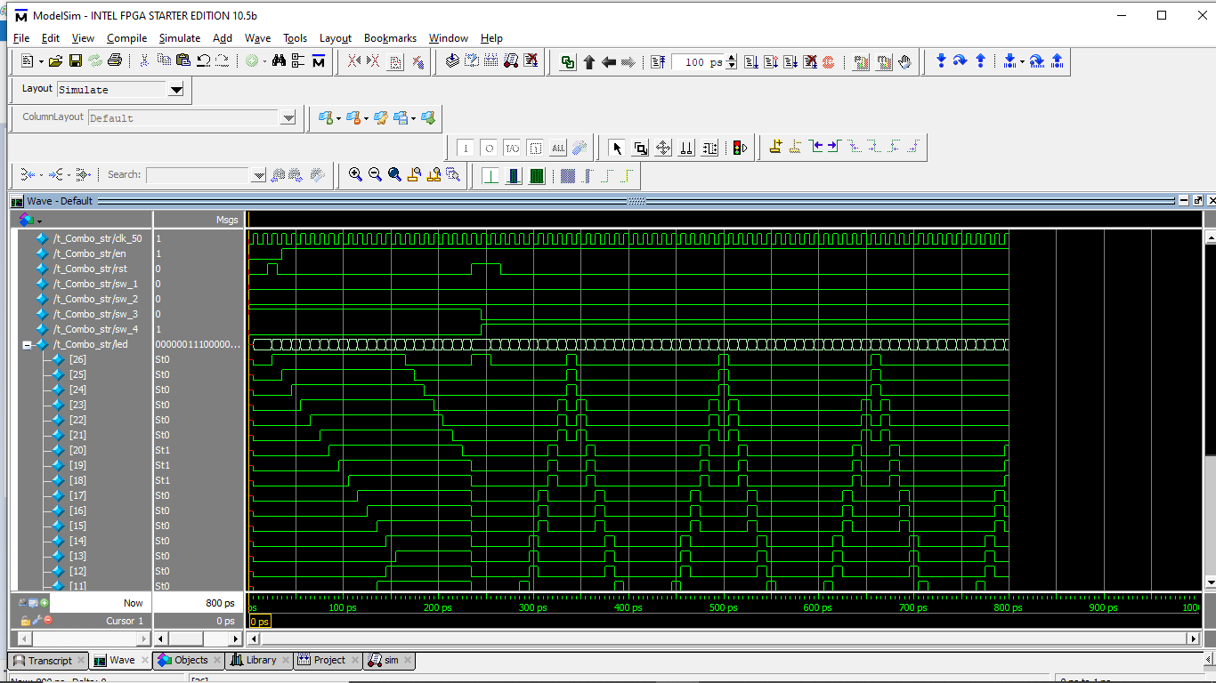

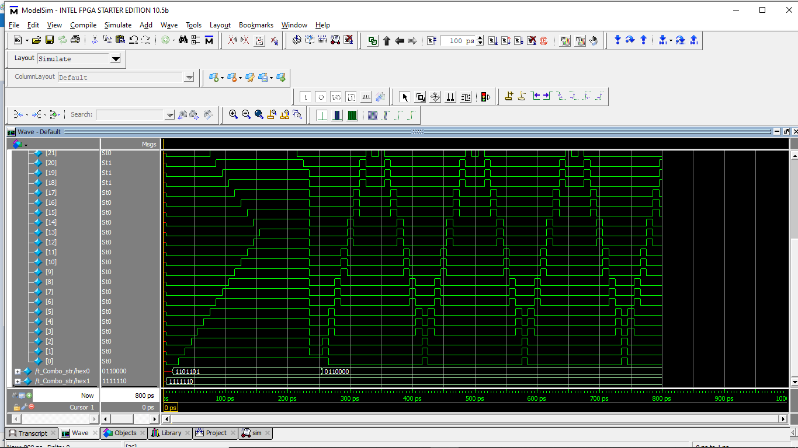

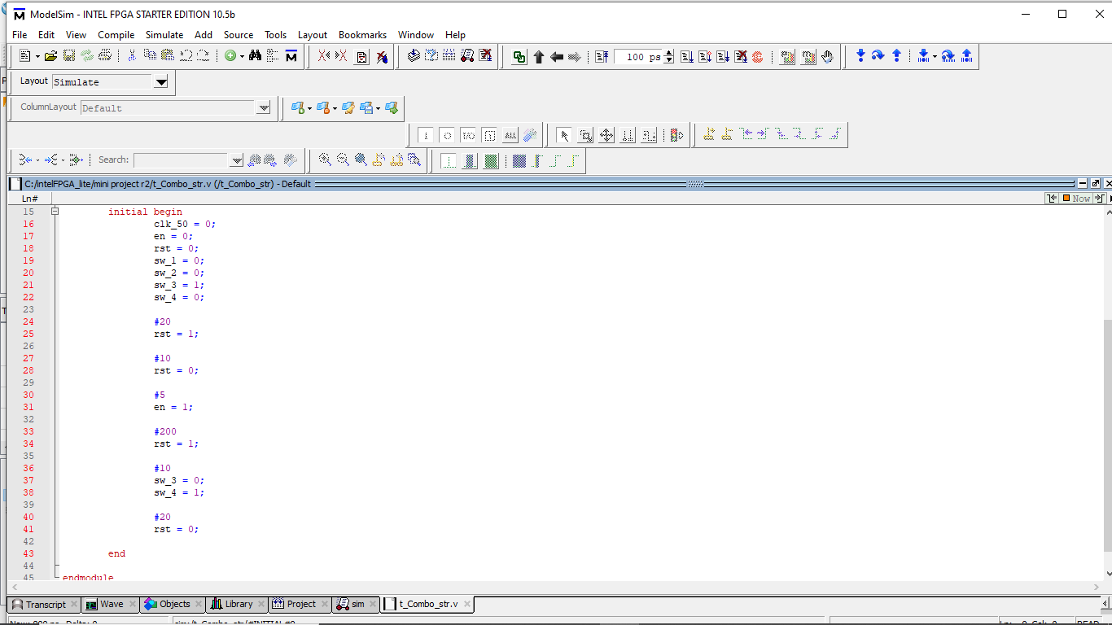

(testbench for mode 2-mode 1)

**MODE 3 (AUTOMATIC) – 50 MHZ**

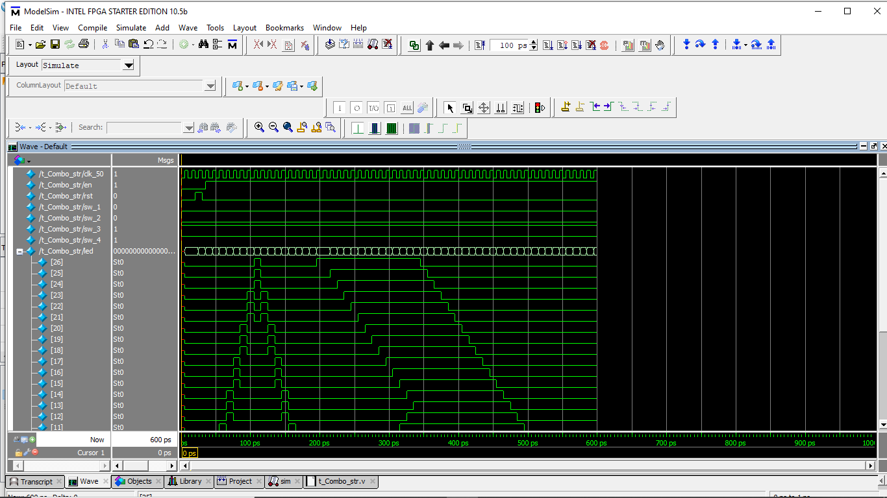

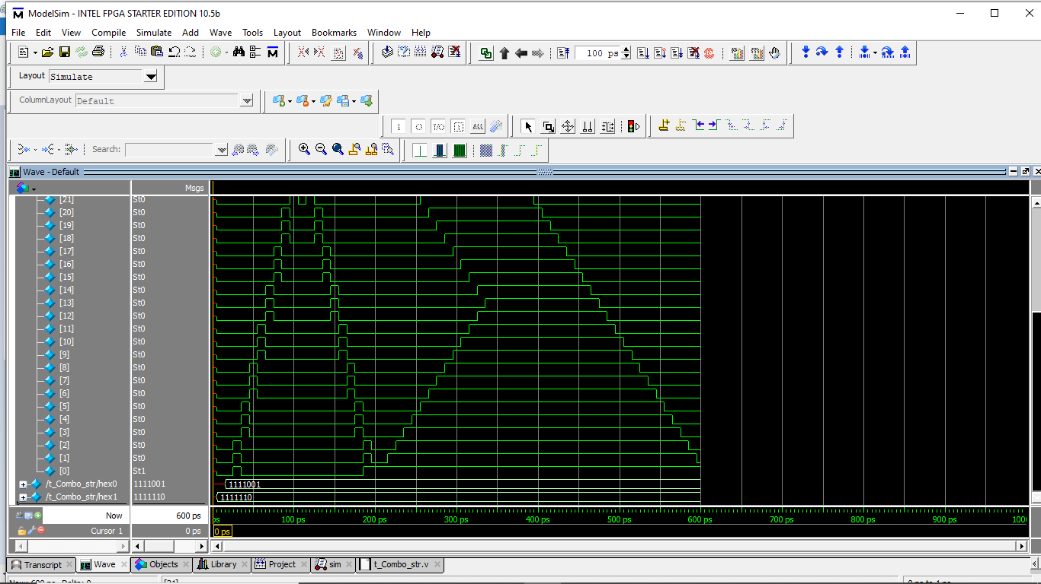

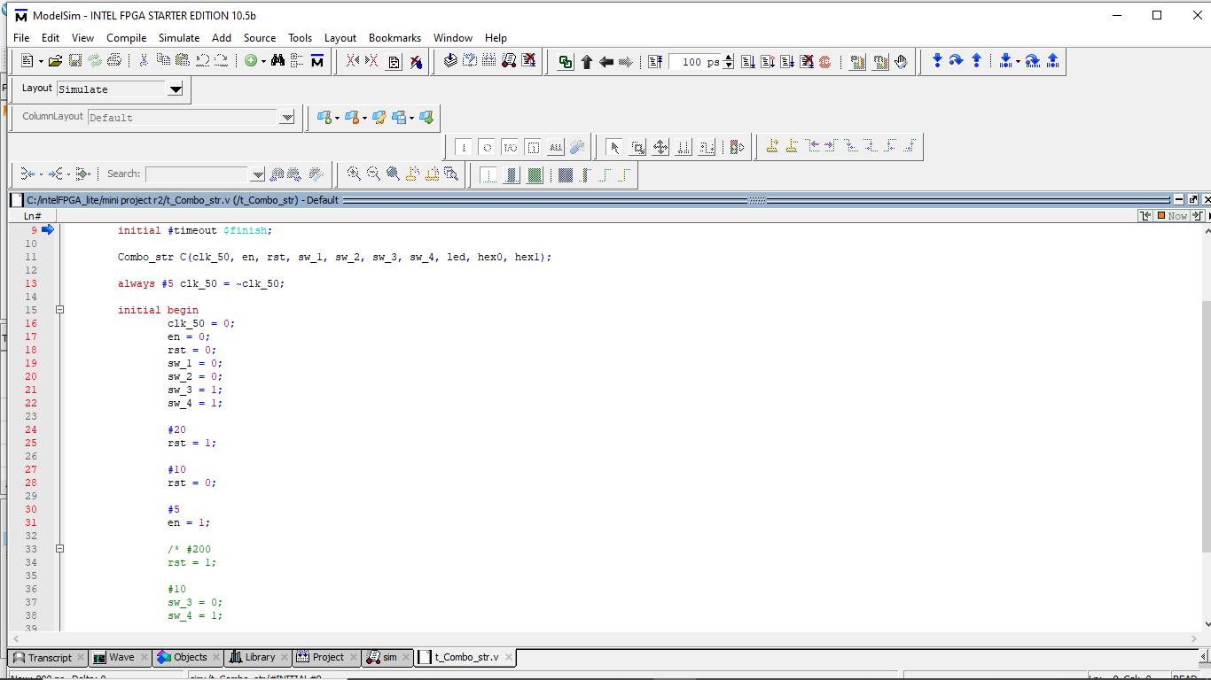

(testbench for mode 3)

**CHAPTER 4: CONCLUSION AND FUTURE WORK**

STRONG/WEAK ASPECTS:

* Strong aspects: easy to operate with simple steps, can run with different frequency and can switch among modes.
* Weak aspects: hard to maintain and modify, as the main modules contain a lot of codes, especially mode 3 case with many nested if-else statements.

CONCLUSION:

Running LEDs is usually used for decorating stores, buildings, companies. A Running LEDs circuit should support multiple running types. This is the first step to understand and practice on electrical circuits.

**LINK (REPORT, VERILOG CODEs & PICTUREs):**

https://drive.google.com/drive/folders/1wy285Zsd5sYwbxgYdZ6HzD2tn5iAathA?usp=sharing

(folder *codes* includes: Control_Unit.v, Datapath_Unit.v, Combo_str.v, t_Combo_str.v, Clock_Div.v, Mode_Select.v and Led7_Decoder.v)

**DUTY ROSTER:**

|  |  |  |
| --- | --- | --- |
| **MAIN CODER, IDEA & REPORT** | **IDEA, SUPPORT** | **SUPPORT** |
| Việt Tú | Minh Trung | Khôi Nguyên |